**Indentation of Code**

Before we proceed further in writing code, we should know how the program is supposed to be written by the developers. For this, we need to understand what a Code Block is.

**What is a Code Block?**

A block is a group of statements in a program or script. Usually, it consists of at least one statement and declarations for the block, depending on the programming or scripting language.

Programming languages usually use certain methods to group statements into blocks.

For example in C/C++, the statements can be grouped into a code block by using the braces "{}",

#include<iostream.h>

void main(){

cout<<"Im inside code block 1";

for(int i=0;i<=10;i++){

cout<<"Im inside code block 2";

for(int j=0;j<=10;j++){

cout<<"Im inside code block 3";

}

cout<<"Im inside code block 2";

}

cout<<"Im inside code block 1";

}

Notice that the code above is readable. Now, have a look at the below code which is written by a programmer who did not indent their code,

#include<iostream.h>

void main(){cout<<"I'm in code block 1.";

for(int i=0;i<=10;i++){cout<<"I'm in code block 2.";}cout<<"I'm in code block 1.";}

Though nothing is technically wrong about the program above, it is difficult for a human to understand what it is trying to do.

**So what is a code block in Python?**

Python takes readability a step further by enforcing strict rules for writing code. Code blocks in python are defined by their indentation.

In the case of Python, it's a language requirement, not a matter of style. This principle makes it easier to read and understand other people's Python code.

So, how does it work? All statements with the same distance from the right belong to the same block of code, i.e. the statements within a block line up vertically. The block ends at a line less indented or the end of the file. If a block has to be more deeply nested, it is simply indented further to the right.

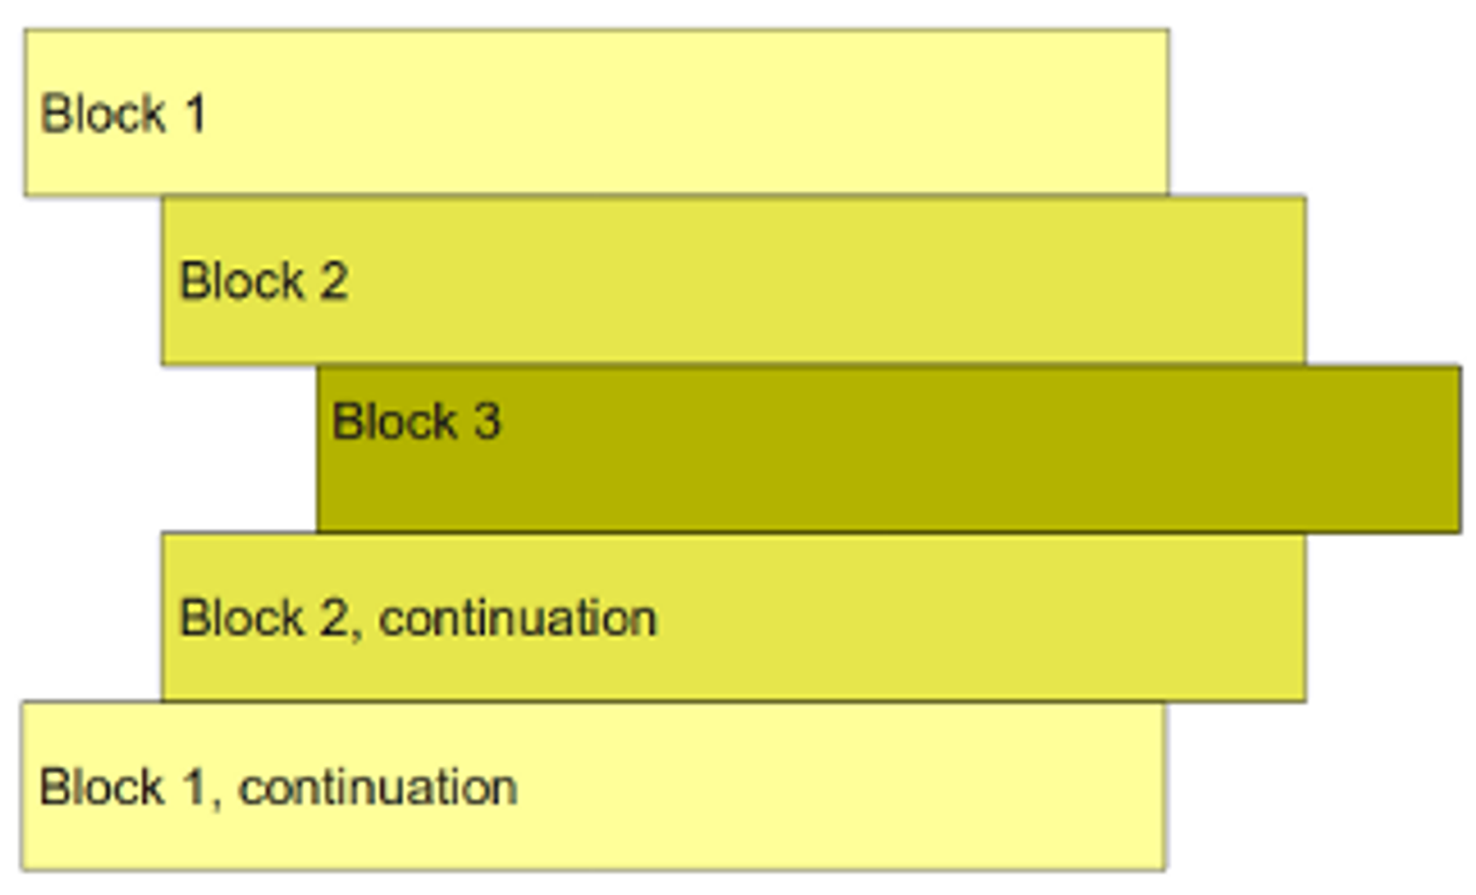

The same code can also be written using Python as,

print("This is block 1")

print("This is also block 1")

for i in range(10):

print("This is code block 2")

for j in range(10):

print("This is code block 3")

print("This is code block 2")

print("This is block 1")